Melamin Foam

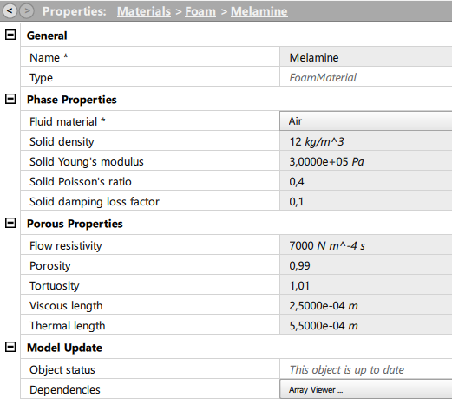

Plate

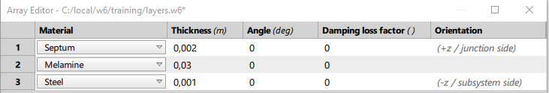

Septum has rho = 1200 kg/m^3

2.4 kg/m^2

